 |  | 
Faculty of Technology and Engineering
Chandubhai S. Patel Institute of Technology (CSPIT)
Department of Computer Science & Engineering
Date: 29/09/2026
Laboratory Manual
Academic Year | : | 2026-27 | Semester | : | 3rd
Course code | : | ITUE203 | Course name | : | WEB DEVELOPMENT FRAMEWORKS

Practical – 5
Registration Form with Frontend Validation and User-Friendly Error Handling
Problem Statement:- Create a student registration form with HTML5 input types and JavaScript validation for name, email, mobile number, password, confirm password, course, year, gender, and terms acceptance. Use Regular Expression for
validations.
Objective:- To create a student registration form using HTML5 input types and JavaScript validation with Regular Expressions (Regex) to validate the name, email, mobile number, password, confirm password, course, year, gender, and terms acceptance.
Github Repository Link:-
https://github.com/Nishtha-cse/StudentHubPortal-D26CS129

FORM VALIDATION USING REGEX :
Register.html:
<div class="register-head">
<span class="register-badge" aria-hidden="true"><i class="bi bi-person-vcard"></i></span>
<h1>Student Registration</h1>
<p>Fill in your details below to set up your StudentHub academic profile.</p>
</div>

<!-- novalidate: browser's default popups are turned off, our JavaScript shows the errors -->
<form id="registerForm" action="#" method="POST" novalidate>

<!-- FULL NAME -->
<div class="form-group">
<label for="fullname">Full Name <span class="required" aria-hidden="true">*</span></label>
<div class="input-wrapper">
<span class="input-icon" aria-hidden="true"><i class="bi bi-person"></i></span>
<input type="text" id="fullname" name="fullname" class="form-control"
placeholder="e.g. Rahul Sharma" autocomplete="name" maxlength="50"
aria-describedby="fullnameError" required>
</div>
<small class="error-message" id="fullnameError" role="alert"></small>
</div>

<!-- EMAIL & MOBILE -->
<div class="form-grid-2">
<div class="form-group">
<label for="email">Student Email <span class="required" aria-hidden="true">*</span></label>
<div class="input-wrapper">
<span class="input-icon" aria-hidden="true"><i class="bi bi-envelope"></i></span>
<input type="email" id="email" name="email" class="form-control"
placeholder="student@example.com" autocomplete="email"
aria-describedby="emailError" required>
</div>
<small class="error-message" id="emailError" role="alert"></small>
</div>

<div class="form-group">
<label for="mobile">Mobile Number <span class="required" aria-hidden="true">*</span></label>
<div class="input-wrapper">
<span class="input-icon" aria-hidden="true"><i class="bi bi-phone"></i></span>
<input type="tel" id="mobile" name="mobile" class="form-control"
placeholder="10-digit mobile number" autocomplete="tel"
maxlength="10" inputmode="numeric"
aria-describedby="mobileError" required>
</div>
<small class="error-message" id="mobileError" role="alert"></small>
</div>
</div>

<!-- GENDER -->
<fieldset class="form-group">
<legend>Gender <span class="required" aria-hidden="true">*</span></legend>
<div class="gender-radio-group" aria-describedby="genderError">
<label class="gender-option">
<input type="radio" name="gender" value="male">
<span class="gender-pill"><i class="bi bi-gender-male" aria-hidden="true"></i> Male</span>
</label>
<label class="gender-option">
<input type="radio" name="gender" value="female">
<span class="gender-pill"><i class="bi bi-gender-female" aria-hidden="true"></i> Female</span>
</label>
<label class="gender-option">
<input type="radio" name="gender" value="other">
<span class="gender-pill"><i class="bi bi-gender-ambiguous" aria-hidden="true"></i> Other</span>
</label>
</div>
<small class="error-message" id="genderError" role="alert"></small>
</fieldset>

<!-- COURSE & YEAR -->
<div class="form-grid-2">
<div class="form-group">
<label for="course">Course <span class="required" aria-hidden="true">*</span></label>
<div class="input-wrapper">
<span class="input-icon" aria-hidden="true"><i class="bi bi-book"></i></span>
<select id="course" name="course" class="form-select" aria-describedby="courseError" required>
<option value="">Select Course</option>
<option value="cse">B.Tech - CSE</option>
<option value="it">B.Tech - IT</option>
<option value="bca">BCA</option>
<option value="mca">MCA</option>
</select>
</div>
<small class="error-message" id="courseError" role="alert"></small>
</div>

<div class="form-group">
<label for="year">Academic Year <span class="required" aria-hidden="true">*</span></label>
<div class="input-wrapper">
<span class="input-icon" aria-hidden="true"><i class="bi bi-calendar3"></i></span>
<select id="year" name="year" class="form-select" aria-describedby="yearError" required>
<option value="">Select Year</option>
<option value="1">1st Year</option>
<option value="2">2nd Year</option>
<option value="3">3rd Year</option>
<option value="4">4th Year</option>
</select>
</div>
<small class="error-message" id="yearError" role="alert"></small>
</div>
</div>

<!-- PASSWORD & CONFIRM PASSWORD -->
<div class="form-grid-2">
<div class="form-group">
<label for="password">Password <span class="required" aria-hidden="true">*</span></label>
<div class="input-wrapper">
<span class="input-icon" aria-hidden="true"><i class="bi bi-lock"></i></span>
<input type="password" id="password" name="password" class="form-control"
placeholder="At least 8 characters" autocomplete="new-password" minlength="8"
aria-describedby="strengthText passwordError" required>
</div>

<!-- Password strength meter -->
<div class="password-strength" aria-hidden="true">
<div id="strengthBar"></div>
</div>
<small id="strengthText" class="strength-text">Password strength: &mdash;</small>
<small class="error-message" id="passwordError" role="alert"></small>
</div>

<div class="form-group">
<label for="confirmPassword">Confirm Password <span class="required" aria-hidden="true">*</span></label>
<div class="input-wrapper">
<span class="input-icon" aria-hidden="true"><i class="bi bi-shield-lock"></i></span>
<input type="password" id="confirmPassword" name="confirmPassword" class="form-control"
placeholder="Repeat password" autocomplete="new-password"
aria-describedby="confirmPasswordError" required>
</div>
<small class="error-message" id="confirmPasswordError" role="alert"></small>
</div>
</div>

<!-- ADVANCED EXTENSION: custom CAPTCHA using Canvas (delete this block to remove it) -->
<div class="form-group" id="captchaGroup">
<label for="captchaInput">Security Check <span class="required" aria-hidden="true">*</span></label>
<div class="captcha-box">
<canvas id="captchaCanvas" width="160" height="50" role="img"
aria-label="CAPTCHA image. Press the refresh button if it is unreadable."></canvas>
<button type="button" class="btn-refresh" id="refreshCaptcha">
<i class="bi bi-arrow-clockwise" aria-hidden="true"></i> Refresh
</button>
</div>
<div class="input-wrapper">
<span class="input-icon" aria-hidden="true"><i class="bi bi-key"></i></span>
<input type="text" id="captchaInput" name="captchaInput" class="form-control"
placeholder="Enter the code shown above" autocomplete="off"
aria-describedby="captchaError" required>
</div>
<small class="error-message" id="captchaError" role="alert"></small>
</div>

<!-- TERMS -->
<div class="terms-check">
<input type="checkbox" id="terms" name="terms" aria-describedby="termsError">
<label for="terms">I accept and agree to the <strong>Terms &amp; Conditions</strong> <span class="required" aria-hidden="true">*</span></label>
<small class="error-message" id="termsError" role="alert"></small>
</div>

Style.css:
/* ================= FORM VALIDATION ================= */
:root {
--bg: #eef1fb;
--card: #ffffff;
--ink: #1c2430;
--muted: #5c6773;
--line: #d7dde3;
--primary: #4f46e5;
--primary-dark: #4338ca;
--error: #dc3545;
--ok: #198754;
}

* { box-sizing: border-box; }

body {
margin: 0;
padding: 32px 16px;
font-family: "Segoe UI", system-ui, -apple-system, Roboto, Arial, sans-serif;
background: var(--bg);
color: var(--ink);
line-height: 1.5;
}

/* ---------- Card ---------- */
.register-card {
max-width: 44rem;
margin: 0 auto;
background: var(--card);
border-radius: 16px;
padding: 40px 32px;
box-shadow: 0 10px 30px rgba(0, 0, 0, 0.08);
}

.register-head { text-align: center; margin-bottom: 28px; }
.register-head h1 { font-size: 1.6rem; margin: 12px 0 4px; }
.register-head p { color: var(--muted); font-size: 0.9rem; margin: 0; }

.register-badge {
display: inline-flex;
align-items: center;
justify-content: center;
width: 52px;
height: 52px;
border-radius: 14px;
font-size: 1.5rem;
background: #e8e7fc;
color: var(--primary);
}

/* ---------- Layout ---------- */
.form-group { margin-bottom: 22px; border: none; padding: 0; min-width: 0; }
.form-grid-2 { display: grid; grid-template-columns: 1fr; gap: 0 24px; }
@media (min-width: 40em) {
.form-grid-2 { grid-template-columns: 1fr 1fr; }
}

label, legend {
display: block;
font-weight: 600;
font-size: 0.9rem;
margin-bottom: 6px;
padding: 0;
}
.required { color: var(--error); }

/* ---------- Inputs ---------- */
.input-wrapper { position: relative; }

.input-icon {
position: absolute;
left: 12px;
top: 50%;
transform: translateY(-50%);
color: var(--muted);
pointer-events: none;
line-height: 1;
z-index: 1;
}

.form-control,
.form-select {
width: 100%;
padding: 11px 12px 11px 40px;
font-family: inherit;
font-size: 0.95rem;
color: var(--ink);
background: #fbfcfd;
border: 1px solid var(--line);
border-radius: 8px;
transition: border-color 0.2s ease, box-shadow 0.2s ease;
}

.form-control:focus,
.form-select:focus,
button:focus-visible,
input[type="checkbox"]:focus-visible {
outline: 3px solid #a5b4fc;
outline-offset: 1px;
border-color: var(--primary);
}

/* ---------- Validation states ---------- */
.form-control.invalid,
.form-select.invalid {
border-color: var(--error);
box-shadow: 0 0 0 0.15rem rgba(220, 53, 69, 0.12);
}
.form-control.valid,
.form-select.valid {
border-color: var(--ok);
box-shadow: 0 0 0 0.15rem rgba(25, 135, 84, 0.10);
}

.error-message {
display: block;
min-height: 18px;
margin-top: 5px;
font-size: 0.82rem;
color: var(--error);
}

.success-message {
text-align: center;
margin: 16px 0 0;
font-weight: 600;
color: var(--ok);
}

/* ---------- Password strength ---------- */
.password-strength {
width: 100%;
height: 5px;
margin-top: 8px;
background: var(--line);
border-radius: 10px;
overflow: hidden;
}
#strengthBar {
width: 0;
height: 100%;
transition: width 0.3s ease, background-color 0.3s ease;
}
.strength-text { display: block; margin-top: 4px; font-size: 0.78rem; color: var(--muted); }

/* ---------- Gender (radio buttons styled as pills) ---------- */
.gender-radio-group { display: grid; grid-template-columns: repeat(3, 1fr); gap: 10px; }

.gender-option { position: relative; margin: 0; font-weight: 400; cursor: pointer; }
/* The real radio stays in the page (keyboard + screen reader friendly), only hidden visually */
.gender-option input { position: absolute; opacity: 0; width: 1px; height: 1px; margin: 0; }

.gender-pill {
display: flex;
align-items: center;
justify-content: center;
gap: 6px;
padding: 10px 8px;
font-size: 0.9rem;
background: #fff;
border: 1px solid var(--line);
border-radius: 10px;
transition: background-color 0.2s ease, border-color 0.2s ease, color 0.2s ease;
}
.gender-option:hover .gender-pill { border-color: var(--primary); }
.gender-option input:checked + .gender-pill {
background: #e8e7fc;
border-color: var(--primary);
color: var(--primary);
font-weight: 600;
}
.gender-option input:focus-visible + .gender-pill {
outline: 3px solid #a5b4fc;
outline-offset: 2px;
}

/* ---------- CAPTCHA ---------- */
.captcha-box { display: flex; align-items: center; gap: 10px; flex-wrap: wrap; margin-bottom: 10px; }
#captchaCanvas { border: 1px solid var(--line); border-radius: 8px; background: #f4f6f8; max-width: 100%; }
.btn-refresh {
padding: 8px 14px;
font-family: inherit;
font-size: 0.85rem;
color: var(--ink);
background: #fff;
border: 1px solid var(--line);
border-radius: 8px;
cursor: pointer;
}
.btn-refresh:hover { background: #f1f3f5; }

/* ---------- Terms ---------- */
.terms-check {
display: flex;
flex-wrap: wrap;
align-items: center;
gap: 4px 10px;
margin-bottom: 22px;
}
.terms-check input[type="checkbox"] { width: 16px; height: 16px; accent-color: var(--primary); }
.terms-check label { margin: 0; font-weight: 400; }
.terms-check .error-message { margin-top: 0; min-height: 0; }

/* ---------- Submit button ---------- */
.register-button {
display: flex;
align-items: center;
justify-content: center;
gap: 8px;
width: 100%;
padding: 13px;
font-family: inherit;
font-size: 1rem;
font-weight: 600;
color: #fff;
background: var(--primary);
border: none;
border-radius: 10px;
cursor: pointer;
transition: background-color 0.2s ease, transform 0.2s ease;
}
.register-button:hover { background: var(--primary-dark); }
.register-button:active { transform: scale(0.98); }

@media (prefers-reduced-motion: reduce) {
* { transition: none !important; }
}

Register.js:

const registerForm = document.getElementById("registerForm");

if (registerForm) {

// ================= GET ELEMENTS =================
const fullname = document.getElementById("fullname");
const email = document.getElementById("email");
const mobile = document.getElementById("mobile");
const password = document.getElementById("password");
const confirmPassword = document.getElementById("confirmPassword");
const course = document.getElementById("course");
const year = document.getElementById("year");
const terms = document.getElementById("terms");
const captchaInput = document.getElementById("captchaInput");

// ================= REGULAR EXPRESSIONS =================

// Only letters and spaces, 3 to 50 characters
const nameRegex = /^[A-Za-z\s]{3,50}$/;

// Basic email format: something@something.domain
const emailRegex = /^[^\s@]+@[^\s@]+\.[^\s@]{2,}$/;

// Indian mobile number: 10 digits, first digit 6-9
const mobileRegex = /^[6-9][0-9]{9}$/;

// Password: minimum 8 characters, at least one uppercase letter,
// one lowercase letter, one number and one special character
// (?=.*X) is a "lookahead": it checks that X exists somewhere in the text
const passwordRegex = /^(?=.*[a-z])(?=.*[A-Z])(?=.*\d)(?=.*[@$!%*?&]).{8,}$/;

// ================= HELPER FUNCTIONS =================
function showError(input, errorId, message) {
input.classList.remove("valid");
input.classList.add("invalid");
input.setAttribute("aria-invalid", "true");
document.getElementById(errorId).textContent = message;
}

function showValid(input, errorId) {
input.classList.remove("invalid");
input.classList.add("valid");
input.setAttribute("aria-invalid", "false");
document.getElementById(errorId).textContent = "";
}

// ================= NAME VALIDATION =================
function validateName() {
const value = fullname.value.trim();

if (value === "") {
showError(fullname, "fullnameError", "Full name is required.");
return false;
}
if (!nameRegex.test(value)) {
showError(fullname, "fullnameError", "Name must contain only letters and spaces.");
return false;
}

showValid(fullname, "fullnameError");
return true;
}

// ================= EMAIL VALIDATION =================
function validateEmail() {
const value = email.value.trim();

if (value === "") {
showError(email, "emailError", "Email is required.");
return false;
}
if (!emailRegex.test(value)) {
showError(email, "emailError", "Enter a valid email address.");
return false;
}

showValid(email, "emailError");
return true;
}

// ================= MOBILE VALIDATION =================
function validateMobile() {
const value = mobile.value.trim();

if (value === "") {
showError(mobile, "mobileError", "Mobile number is required.");
return false;
}
if (!mobileRegex.test(value)) {
showError(mobile, "mobileError", "Enter a valid 10-digit mobile number.");
return false;
}

showValid(mobile, "mobileError");
return true;
}

// ================= PASSWORD VALIDATION =================
function validatePassword() {
const value = password.value;

if (value === "") {
showError(password, "passwordError", "Password is required.");
return false;
}
if (!passwordRegex.test(value)) {
showError(
password,
"passwordError",
"Password must contain 8+ characters, uppercase, lowercase, number and special character."
);
return false;
}

showValid(password, "passwordError");
return true;
}

// ================= CONFIRM PASSWORD =================
function validateConfirmPassword() {
const value = confirmPassword.value;

if (value === "") {
showError(confirmPassword, "confirmPasswordError", "Please confirm your password.");
return false;
}
if (value !== password.value) {
showError(confirmPassword, "confirmPasswordError", "Passwords do not match.");
return false;
}

showValid(confirmPassword, "confirmPasswordError");
return true;
}

// ================= COURSE VALIDATION =================
function validateCourse() {
if (course.value === "") {
showError(course, "courseError", "Please select your course.");
return false;
}

showValid(course, "courseError");
return true;
}

// ================= YEAR VALIDATION =================
function validateYear() {
if (year.value === "") {
showError(year, "yearError", "Please select your academic year.");
return false;
}

showValid(year, "yearError");
return true;
}

// ================= GENDER VALIDATION =================
function validateGender() {
const selectedGender = document.querySelector('input[name="gender"]:checked');
const error = document.getElementById("genderError");

if (!selectedGender) {
error.textContent = "Please select your gender.";
return false;
}

error.textContent = "";
return true;
}

// ================= TERMS VALIDATION =================
function validateTerms() {
const error = document.getElementById("termsError");

if (!terms.checked) {
error.textContent = "You must accept the Terms & Conditions.";
return false;
}

error.textContent = "";
return true;
}

// ==================================================
// PASSWORD STRENGTH METER
// One point for each rule the password satisfies (0 to 5)
// ==================================================
function updatePasswordStrength() {
const value = password.value;
const strengthBar = document.getElementById("strengthBar");
const strengthText = document.getElementById("strengthText");

let score = 0;
if (value.length >= 8) score++;
if (/[A-Z]/.test(value)) score++;
if (/[a-z]/.test(value)) score++;
if (/[0-9]/.test(value)) score++;
if (/[@$!%*?&]/.test(value)) score++;

if (value === "") {
strengthBar.style.width = "0";
strengthText.textContent = "Password strength: \u2014";
} else if (score <= 2) {
strengthBar.style.width = score <= 1 ? "20%" : "40%";
strengthBar.style.backgroundColor = "#dc3545";
strengthText.textContent = "Password strength: Weak";
} else if (score === 3) {
strengthBar.style.width = "60%";
strengthBar.style.backgroundColor = "#e0a020";
strengthText.textContent = "Password strength: Medium";
} else if (score === 4) {
strengthBar.style.width = "80%";
strengthBar.style.backgroundColor = "#2d8f5f";
strengthText.textContent = "Password strength: Good";
} else {
strengthBar.style.width = "100%";
strengthBar.style.backgroundColor = "#198754";
strengthText.textContent = "Password strength: Strong";
}
}

// ==================================================
// ADVANCED EXTENSION: CUSTOM CAPTCHA USING CANVAS
// (delete this whole section + the captcha block in the HTML to remove it)
// ==================================================
const canvas = document.getElementById("captchaCanvas");
const ctx = canvas.getContext("2d");
let currentCaptcha = "";

function generateCaptchaText() {
// 0, O, 1, I and L are left out because they look alike
const chars = "ABCDEFGHJKMNPQRSTUVWXYZ23456789";
let text = "";
for (let i = 0; i < 6; i++) {
text += chars.charAt(Math.floor(Math.random() * chars.length));
}
return text;
}

function drawCaptcha() {
currentCaptcha = generateCaptchaText();

ctx.clearRect(0, 0, canvas.width, canvas.height);
ctx.fillStyle = "#f4f6f8";
ctx.fillRect(0, 0, canvas.width, canvas.height);

// random noise lines
for (let i = 0; i < 5; i++) {
ctx.strokeStyle = "rgba(79, 70, 229, " + (0.15 + Math.random() * 0.2) + ")";
ctx.beginPath();
ctx.moveTo(Math.random() * canvas.width, Math.random() * canvas.height);
ctx.lineTo(Math.random() * canvas.width, Math.random() * canvas.height);
ctx.stroke();
}

// the characters, each slightly rotated and shifted
const spacing = canvas.width / (currentCaptcha.length + 1);
for (let j = 0; j < currentCaptcha.length; j++) {
ctx.save();
ctx.translate(spacing * (j + 1), canvas.height / 2 + (Math.random() * 10 - 5));
ctx.rotate(Math.random() * 0.5 - 0.25);
ctx.font = "bold 24px Arial";
ctx.fillStyle = "#1c2430";
ctx.textAlign = "center";
ctx.textBaseline = "middle";
ctx.fillText(currentCaptcha.charAt(j), 0, 0);
ctx.restore();
}

// random noise dots
for (let k = 0; k < 30; k++) {
ctx.fillStyle = "rgba(28, 36, 48, 0.2)";
ctx.beginPath();
ctx.arc(Math.random() * canvas.width, Math.random() * canvas.height, 1, 0, Math.PI * 2);
ctx.fill();
}
}

function validateCaptcha() {
const value = captchaInput.value.trim().toUpperCase();

if (value === "") {
showError(captchaInput, "captchaError", "Please enter the code shown above.");
return false;
}
if (value !== currentCaptcha) {
showError(captchaInput, "captchaError", "Code does not match. Try again.");
return false;
}

showValid(captchaInput, "captchaError");
return true;
}

document.getElementById("refreshCaptcha").addEventListener("click", function () {
drawCaptcha();
captchaInput.value = "";
captchaInput.classList.remove("valid", "invalid");
captchaInput.removeAttribute("aria-invalid");
document.getElementById("captchaError").textContent = "";
});

drawCaptcha();

// ================= REAL-TIME VALIDATION (INTERMEDIATE EXTENSION) =================
// "input" fires on every key press / paste; "change" fires when a choice is made
fullname.addEventListener("input", validateName);
email.addEventListener("input", validateEmail);

mobile.addEventListener("input", function () {
mobile.value = mobile.value.replace(/\D/g, ""); // allow digits only
validateMobile();
});

password.addEventListener("input", function () {
updatePasswordStrength();
validatePassword();

// re-check confirm password if the user already typed something there
if (confirmPassword.value !== "") {
validateConfirmPassword();
}
});

confirmPassword.addEventListener("input", validateConfirmPassword);
course.addEventListener("change", validateCourse);
year.addEventListener("change", validateYear);
terms.addEventListener("change", validateTerms);
captchaInput.addEventListener("input", validateCaptcha);

document.querySelectorAll('input[name="gender"]').forEach(function (radio) {
radio.addEventListener("change", validateGender);
});

// ================= FORM SUBMISSION =================
registerForm.addEventListener("submit", function (event) {
event.preventDefault(); // stop the page from reloading

// Every validator runs (no short-circuit) so all errors show together
const nameValid = validateName();
const emailValid = validateEmail();
const mobileValid = validateMobile();
const passwordValid = validatePassword();
const confirmPasswordValid = validateConfirmPassword();
const courseValid = validateCourse();
const yearValid = validateYear();
const genderValid = validateGender();
const captchaValid = validateCaptcha();
const termsValid = validateTerms();

const isFormValid =
nameValid && emailValid && mobileValid && passwordValid &&
confirmPasswordValid && courseValid && yearValid &&
genderValid && captchaValid && termsValid;

const successMessage = document.getElementById("successMessage");

if (isFormValid) {
successMessage.textContent = "Registration successful!";

// In a real application,
// data would be sent to the server here.
} else {
successMessage.textContent = "";

// Keyboard users: move focus to the first field with an error
const firstInvalid = registerForm.querySelector(".invalid");
if (firstInvalid) {
firstInvalid.focus();
} else if (!genderValid) {
document.querySelector('input[name="gender"]').focus();
} else if (!termsValid) {
terms.focus();
}
}
});
}

Name Validation:

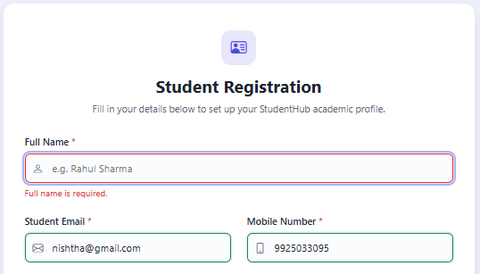

Email Validation :

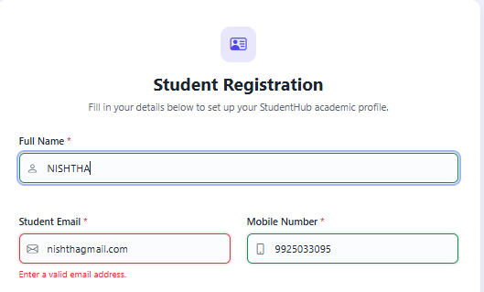
Mobile Number Validation :

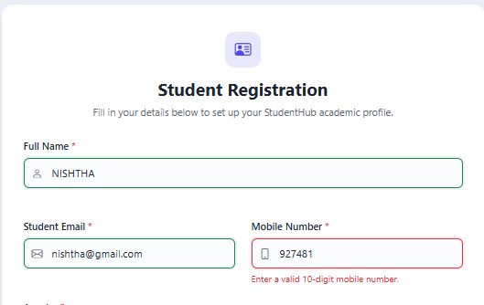
Required Field Validation:
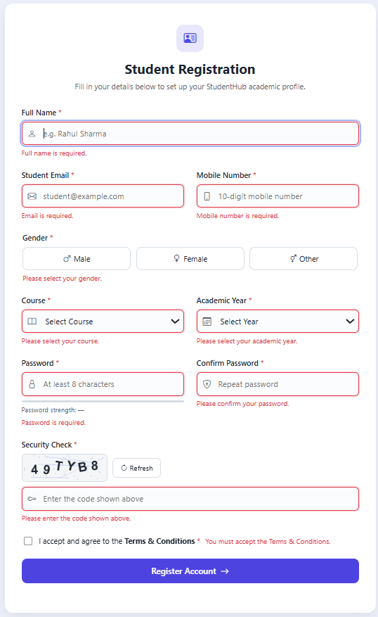
Password Format Validation :
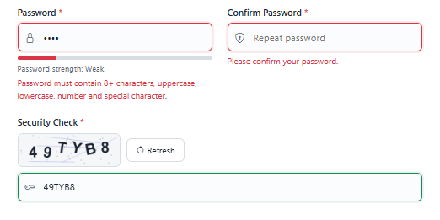

Password Mis-match Validation :
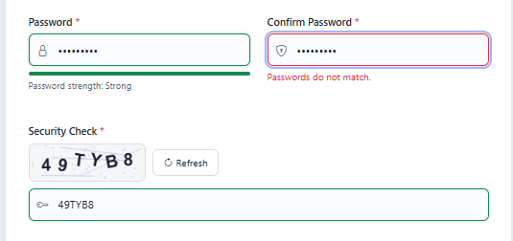
Terms & Conditions Validations :

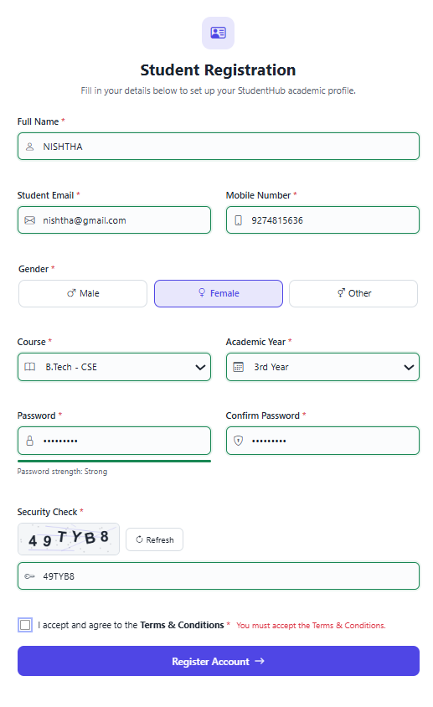

Form with all validations satisfied :
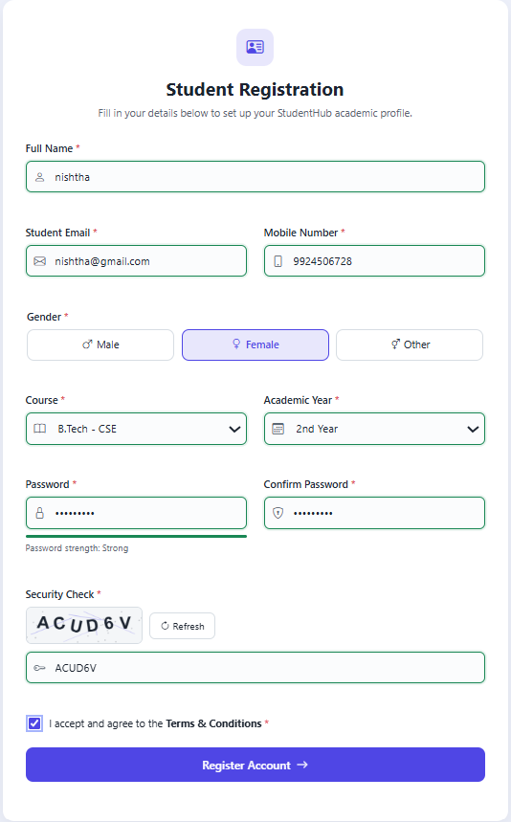

Registration Successful :

